Registration Form
2023 Grand Canyon Regional Ophthalmology Meeting
High Country Conference Center, Flagstaff, AZ, June 2-4, 2023

Name:_______________________________________________________

Address:_______________________________________________________________

City: __________________________________ State: ________ Zip ______________

Email: ________________________________________________________________

_____ AOS member with current dues $250

______ AOS retired member $200

_____ AOS resident member no fee

_____ AOS Nonmember $300

_____ I will attend reception on 6/2, # Guests ________ _____I will attend reception on 6/3, # Guests _____

_____ I will attend OMIC seminar on 6/4 _____ I will only attend OMIC seminar on 6/4

Make check payable to the Arizona Ophthalmological Society or pay by Visa, MasterCard, or AMEX and send to 2401 W. Peoria Ave., Suite 315, Phoenix, AZ 85029, email to Linda DiBiase, ldibiase@azmed.org or fax to (602) 242-6283.

Please follow this link for online payment:
https://secure.affinipay.com/pages/arizona-medical-association-inc/arizona-ophthalmological-society-inv

Or scan QR code:

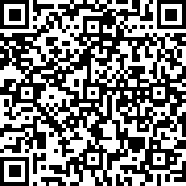

Credit Card _____________________________________________________________________

Exp Date ________________________________ CVC # _______________________________________

Billing address _____________________________________________________________________________

Email address for receipt ____________________________________________________________________

Hotel Information
We have a reserved room block at the Drury Inn & Suites, 300 S Milton Rd, Flagstaff, AZ 86001. The deadline for reservations at our group rate is May 12, 2023. Please contact the hotel at 1-800-325-0720 or visit their website www.druryhotel.com and reserve your room under group #2402366, Arizona Ophthalmological Society 2023 Grand Canyon Regional Ophthalmology Meeting.

Cancellations received up to 96 hours preceding the conference will be refunded minus a $40.00 administrative fee. No refunds will be made on cancellations received after May 28, 2023.

